ANNUAL HEALTH AND SAFETY MANAGEMENT PLANS PROCEDURE
SECTION 3 Framework for Health and Safety Management

PURPOSE
PROCEDURE

To provide an outline for the establishment and review of an organisational wide annual health and safety management plan.

DEVELOPMENT OF ANNUAL HEALTH AND SAFETY MANAGEMENT PLAN

SCOPE OF PLAN

The management plan will apply to all operations and activities undertaken and will include the following elements:

 Scheduled Audit Activities

 Scheduled Workplace Inspections

 Consultation Activities and meetings

 Key Initiatives to address identified strategic improvement areas

 Review of documents and tools within the health and safety management system

 Health and Safety Training Activities

 Performance Reporting

DEVELOPMENT OF THE PLAN

The Health and Safety Manager will develop a draft annual plan in line with the organisation’s business objectives planning cycle. Typically this is done at the end of the financial year, to
ensure that budget allocations can be incorporated into the new financial cycle.

The plan is tabled at the Health and Safety Consultative Committee for input and review before being presented for endorsement at the Strategic Governance Group.

TRACKING AND REVIEWING THE PLAN

Progress on actions and activities contained within the management plan is reported to the Health and Safety Consultative Committee. The plan shall be updated monthly by the Health and Safety Manager to ensure it is relevant and reflective of the actions being completed or progressed.

Situations where programs or initiatives are not completed, or there are barriers to effective implementation will provide a
source of insight for the Health and Safety Manager to report to the Health and Safety Governance Group. For example if training activities are continually cancelled due to non-attendance then the strategic group may determine an initiative to ensure workers attend required training. In other instances, where there is no significant trend or strategic element to the failure of completed activities then the Health and Safety Manager may develop actions and monitor for effectiveness.

UPDATE AND MODIFICATION OF ACTIONS AND INITIATIVES

Additional actions or initiatives may be developed and included into the plan, typically from the following sources:

 Organisation-wide corrective actions from incidents and audits.

 Initiatives endorsed by the Strategic Governance Group in response to information contained in insight reports.

 Direction or notice from WorkSafe NZ or other relevant third party.

The Health and Safety Manager shall ensure that additional activities are included in the plan and subsequently tracked and managed as described above.

RECORD KEEPING

Copies of Annual management plans shall be retained for two years by the Health and Safety Manager.

REFERENCES

WATER NEW ZEALAND PROCEDURES & GUIDELINES:

Health and Safety Procedures:

 Health and Safety Strategic Management Group

 Annual Health and Safety Audit Program

 Health and Safety Consultation and Communication Procedure

 Health and Safety Training Program

Health and Safety Guidelines:

 None

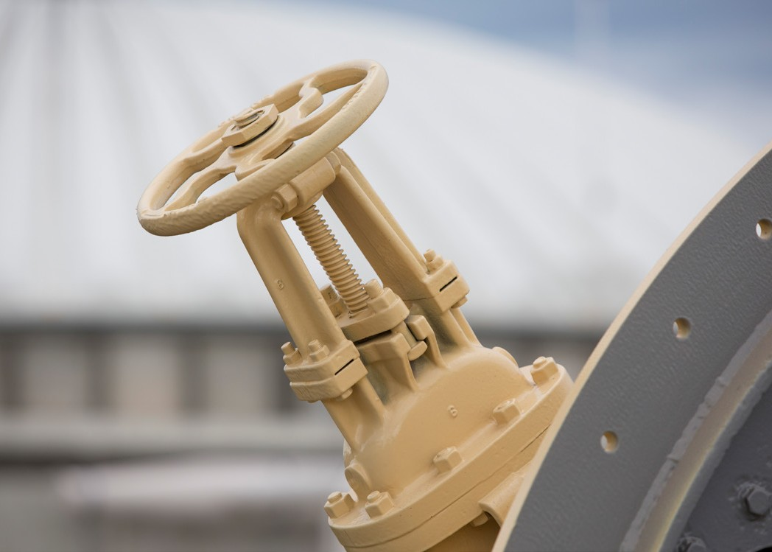
LEGISLATION, REGULATION AND STANDARDS

 Health and Safety at Work Act 2015
SECTION 3 Framework for Health and Safety Management

 Health and Safety at Work (Worker Engagement, Participation and Representation) Regulations 2016

ATTACHMENTS
PROCEDURE

Attachment 1: Annual Health and Safety Management Plan Template

