Going green: costs and benefits of living roofs on bus shelters in auckland

C. Bebelman (Auckland Transport), S. Ira (Koru Environmental), R Simcock (Manaaki Whenua Landcare Research), L. Shamrock (Pattle Delamore Partners)

ABSTRACT
- Introduction
Urbanisation can lead to the removal of integral eco-system services, reduce the accessibility, quality, and quantity of greenspaces, fragment habitats and exacerbate the impact of climate change, reducing the resilience of communities to its effects. Coupled with a large and increasing proportion of urban populations there is a distinct need to regenerate nature in urban settings, a goal aligned with United Nations Sustainable Development Goals; Sustainable Cities and Communities (11), Life on Land (15), and Health and Wellbeing (3), and is also strongly supported throughout C40 Cities, of which Auckland is one.
Traditional approaches to regenerating nature like reforestation and constructed wetlands are less practical in ultra-urban areas where available space is strictly limited and any urban areas where land has high NZ$ value as building sites. Innovative approaches are therefore needed to facilitate the seamless integration of nature with vital urban infrastructure and to promote not only regeneration, but also reimagining what nature looks like in an urban setting.
In response to these global problems, Auckland Transport (AT) is trialling lightweight, living roofs on two Auckland bus shelters as part of their focus on sustainable and environmental solutions for public transport initiatives. A large bus shelter (194 m²) at the Panmure Transport Centre, and a small bus shelter (9.5m²) outside Redoubt North School in Manukau were retrofitted with plants growing in a media up to 150 mm deep. Such roofs generally have a structural loading of 60 – 300 kg/m² (Hargreaves, 2006, Fassman-Beck et al 2010) and support low-growing vegetation such as herbs, rushes, grasses, sedums and other succulents, wildflowers, summer-dormant bulbs and, in Auckland, lithophytes and epiphytes such as bromeliads and tank lilies.

The goal of the pilot project was to design extensive living roofs which can be retrofitted, easily maintained, and which maximise four prioritised benefits:
- To contribute to the well-being of Aucklanders by providing bus stops which filter air pollutants, reduce the urban heat island effect and provide some aesthetic benefits;
- To contribute to local native biodiversity and/or pollinator pathways, increasing ‘nature’ in the roadside environment;
- To reduce impervious surfaces within the city and provide stormwater quantity reduction benefits; and
- Provide an opportunity to better evaluate the role of living roofs in climate change adaptation and the building of resilient communities.

- Design and Structural Considerations
The bus stops needed to accommodate the weight of the “regular” roof, as well as the components of the living roof system under normal operating conditions (Fassman-Beck and Simcock, 2013). Both bus shelter structural loading requirements fell within the approximate ‘saturated’ weight of a relatively thin and lightweight (low-profile) green roof (80-100 kg/m² range).
The general public’s (and AT’s) assessment of performance of a living roof is often judged by the health and appearance of plants, hence choosing suitable plants, management and sites is important. The choice of plants depends on the sun (and wind) exposure, the availability of irrigation and water stored in the substrate (i.e. frequency and severity of drought stress). Irrigation, as was incorporated into the larger Panmure bus shelter, is used to maintain plant aesthetics through summer and allow taller plants to be used, increasing aesthetic benefits. Solar panels have been incorporated into the design for minor bus shelters and have been used on the Redoubt North School bus shelter. Lower-growing plants (sedums) were planted around the solar panels where they received maximum sun exposure. Taller plants were planted towards the edges of the bus shelter where they could be seen by commuters. The design objectives and plant choices also have significant maintenance implications.

- Implementation
The living roofs and walls were commissioned between October and November 2021. In the 12 months following their construction, the performance of the shelters under the planned maintenance programme was assessed. Maintenance visits were included in the installation contract; a scissor lift was used to maintain health of the vegetation including weeding, trimming and fertilising plants, and to inspect and optimise the irrigation systems. The review has highlighted that the maturity of the plants and time/ season of installation can have a significant impact on the level of maintenance needed during the first 12 months of operation. The system used was able to be ‘pre-grown’ before installation, but a short lead-in time reduced the range of plant species able to be used and the maturity of the system at installation. A more mature system with higher initial plant cover is generally more resistant to weeds.

- Stakeholder Engagement
Stakeholder engagement within AT and at the school was essential to the success of the project, particularly with the Ōtara-Papatoetoe Local Board and Redoubt North Primary School. Engagement activities included developing and implementing an educational outreach programme. The programme focussed on building an enviro-club within the school and running a series of educational sessions on stormwater management and integrating nature into the urban environment (including a site visit to the Auckland Botanic Gardens). This programme encouraged students to be involved in the design process of the green roof, enabling a sense of ownership and pride for the students. The children were even involved in the opening ceremony. Collaboration with the local board and school ensured that the project’s neighbours could take ownership of and become guardians for the shelter, thus helping to safeguard against vandalism, and enhance awareness for the abundance of benefits it offers.

- Understanding the Long Term Costs and Benefits of Living Roofs
Using a life cycle costing (LCC) approach, the potential construction and long-term maintenance costs of the proposed living roof designs were estimated. On average, a small sized (approximately 10m²) living roof has a low indicative LCC estimate of $32/m²/yr and a high indicative LCC estimate of $62/m²/yr over a 50 year analysis period at a 4% discount rate (2018 base date). The LCC results demonstrate a right-skewed distribution of costs (i.e., an increase in device surface area leads to a decrease in LCC). This relationship is likely caused by the predominating effect of long term maintenance costs on Total Acquisition Cost (TAC) as some of the maintenance and associated cost is device specific (e.g., inspections – individual roofs need to be inspected regardless of size) and needs to be undertaken for both small and large roof areas (i.e., it is independent of total roof area, ensuring a lesser relative cost for larger devices). This leads to clear economies of scale being achieved for larger roofs or wide-spread implementation of smaller roofs in close proximity to each other. Results show that the majority of the LCC is related to ongoing routine maintenance of the living roof (approximately 60% - 70% of the total LCC).
Living roofs typically also deliver a range of environmental, economic, and social benefits, many of which are non-water related. The bus shelters were designed to deliver aesthetic benefits (greening of the urban environment), air purification (by carbon sequestration), extension of roof life, reduction of ambient air temperature, increased biodiversity/ habitat, stormwater flow and volume reduction, noise reduction and support for insect pollination. The “More Than Water” tool (Moores, et al., 2019) was used to graphically illustrate potential benefits of living roofs on bus shelters. “More Than Water” (MTW) was designed to enable qualitative assessments of differences in the benefits and costs of alternative green infrastructure project scenarios. As shown in Figure 1, conventional bus shelters are likely to only elicit benefits around ambient air temperature and public health (in that they keep patrons dry and shaded), other benefits would be classified as “None” in the MTW tool. Living roofs, on the other hand, elicit numerous non-water and water-related benefits (Figure 1). The assessment assumes a cumulative effect from a wider roll-out of living roofs on bus shelters rather than individual bus shelters themselves.
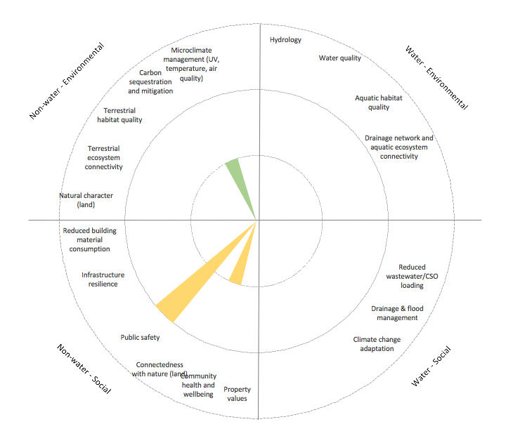
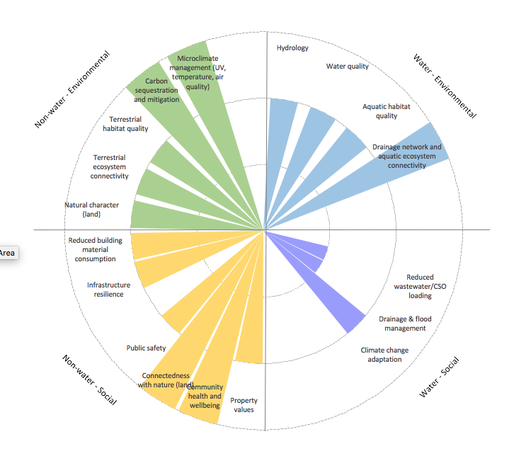
- living roof bus shelters (b) conventional bus shelters
Figure 1: More Than Water benefits assessment for bus shelters with living roofs. Note benefits would differ for different designs (including complementary features), locations and maintenance.
In conclusion, whilst living roofs may be more expensive than conventional roofs, especially when retrofit, they can provide a range of benefits delivered by plants, growing medium and water storage (Figure 1). In addition to enhancing urban environments, these benefits can range from improving microclimates, carbon sequestration, and connecting people with nature and improving community well-being, to stormwater and aquatic habitat benefits. These benefits are especially evident through bus shelters if the roof area is large, the surrounding areas are bare of plants, and the plants are bulky and visible (from the ground and/or adjacent buildings). These roofs also contribute to resilience of the road corridor by providing an option for assessment under ATs climate change adaptation approach.

References
Fassman, E.A.; Simcock, R..; Voyde, E. 2010. Extensive Green (Living) Roofs for Stormwater Mitigation: Part 1 Design and Construction. Prepared by Auckland UniServices for Auckland Regional Council. Auckland Regional Council Technical Report 2010/017.
Fassman-Beck, E A and Simcock, R. 2013. Living roof review and design recommendations for stormwater management. Prepared by Auckland UniServices for Auckland Council. Auckland Council Technical Report TR2013/045.
Hargreaves, R. 2006. Green roofs worth their weight in gold. “BUILD” magazine, October/ November 2006.
Moores, J., Ira, S., Batstone, C. and Simcock, R. 2019. The ‘More than Water’ WSUD Assessment Tool.’ Research report to the Building Better Homes, Towns and Cities National Science Challenge.

KEYWORDS
Green roofs, maintenance, stakeholder engagement, life cycle costs, non-water benefits

Lithophytes are plants that grow on rocky outcrops.
Epiphytes are plants which grow in trees.

